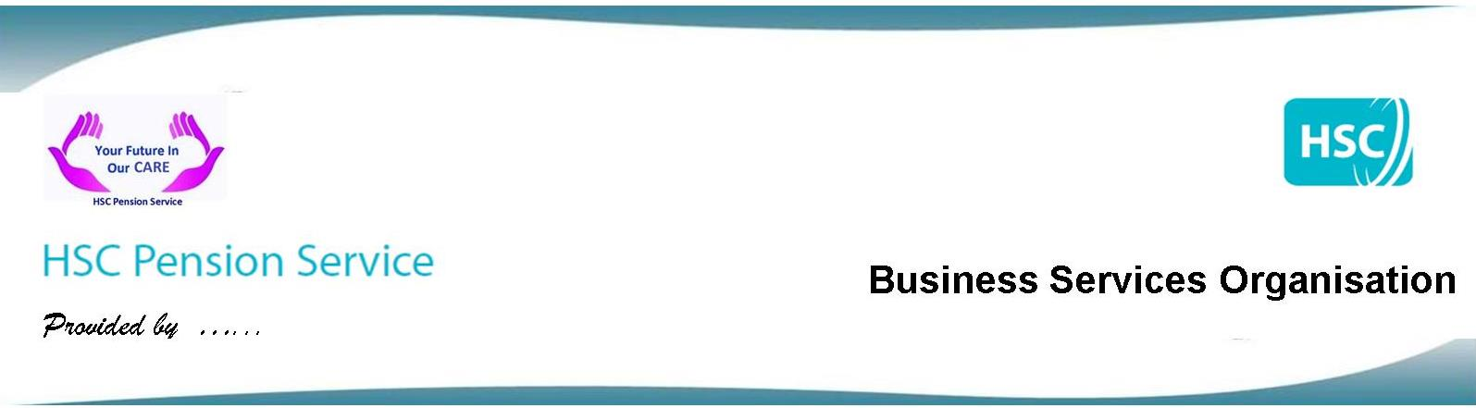
HSC Coronavirus Life Assurance Scheme Dispute Resolution Guidance

What will the HSC Pension Service do, if something goes wrong?

If you think we have made a mistake, you don’t agree with our decision, or you feel we have not dealt with your case very well, we have a procedure for dealing with disputes which aims to give you a response which answers your concerns.

Who can use our disputes procedure?

Anyone who has made a claim to the HSC Coronavirus Life Assurance Scheme.

You will need to complete the form CVDP1 to start the disputes procedure. The CVDP1 form is available on our website in the same section as this guidance. You must provide:

- your full name and address
- the name, date of birth, date of death and National Insurance number of the person for which the claim has been made
- the reference number of the claim (which is quoted on any correspondence from us)
- the reason you are complaining

We may need to ask for a form of authority before we can disclose information to you if you are not the person who made the original claim.

What happens next?

A Disputes Officer will review and carefully consider each point made in your dispute application. We will tell you the outcome in writing. This is a Stage One Dispute Resolution (DR). We will:

- explain the decision, and whether there has been a change to any previous decision
- refer to any rules or law affecting the decision
- refer to any other papers which were important in reaching the review decision and indicate where any discretion under the rules has been given
- give the name and address of the person reviewing the case and who any further correspondence should be sent to

We will reply within 14 working days or tell you if we are unable to do so. We will keep you informed of progress.

You are entitled to have your case looked at a second time, if you are dissatisfied with the review decision. If you want to do this, you should do so within one calendar month of the date on your review decision. The second review will be carried out by a Disputes Manager who will reply within 14 working days or tell you if they are unable to do so. Again we will keep you informed of progress. This is a Stage Two Dispute Resolution (DR).

Our commitment to dealing with disputes

All replies will be as open and helpful as possible. Our staff will ensure that:

- decisions are not outside the Scheme rules
- there has been no abuse of any discretionary powers within the meaning of the Scheme rules
- the facts of the case and the reasoning behind the matter at issue are clearly explained
- there has been no breach of the two fundamental rules of natural justice - which are, the right of appeal before a decision is taken affecting one’s interest and the absence of bias on the part of the decision maker

We have a duty to act fairly and reasonably at each stage of the decision making process and subsequently under the review procedure.

Our staff will:

- Be informed - making sure they have all the facts or evidence in support of the case

- Be fair – by taking account only of relevant facts and making sure they have addressed the correct question

- Be open minded - being prepared to give full consideration to any new facts or evidence

- Be reasonable - making reasonable assumptions in the case under consideration

You can email your dispute application to us at: nhsbsa.coronaviruslifeassurancescheme@nhs.net or you can
send it to us by post.

Our address is: HSC Pension Service
Waterside House
75 Duke Street
Derry
BT47 6FP

